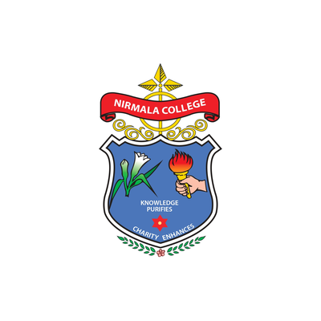  Nirmala College for Women  ACADEMIC HOST |   Digital South Trust  KNOWLEDGE PARTNER

CENTRE OF EXCELLENCE • INNOVATION HUB • EST. 2026
Blockchain Centre of Excellence
Where education, innovation, research and industry converge.
• • •

About the Centre
The Blockchain Centre of Excellence is a future-focused innovation hub created to help students, faculty, startups, researchers and industry partners learn, build and scale real-world technology solutions.
The Centre focuses on Blockchain, Web3, Smart Contracts, Digital Trust, Cybersecurity, Software Development, Web Applications, Mobile Applications, AI-enabled solutions and Startup Innovation — bringing them together under one roof on the Nirmala College for Women campus.
"Building India's digital future, one skilled professional, innovator, and founder at a time"

Why the Centre Matters
Blockchain has moved well beyond cryptocurrency. It now underpins secure, transparent and trusted digital systems across finance, governance, healthcare, education, supply chain, identity, sustainability and enterprise technology — and the talent gap in these areas is widening every year.
India’s next decade of digital growth will be built by professionals who can design, secure and deploy these systems in production. The Blockchain Centre of Excellence is built to develop precisely that talent — in an environment where coursework, research, hands-on labs and startup mentoring sit side-by-side.

Our Focus Areas
The work of the Centre is organised around seven interconnected pillars. Together they form a complete pathway from learning to research to industry-ready solutions.
01 Blockchain Innovation and Research
The Centre supports research, proof-of-concepts, prototypes and real-world blockchain use cases across education, finance, healthcare, agriculture, supply chain, governance, cybersecurity and sustainability.
02 Curriculum and Skill Integration
Blockchain, Web3, software development, web development and application development are introduced through foundation courses, practical labs, certification modules, workshops, capstone projects and real-world problem-solving activities.
03 Startup Incubation and Mentoring
Student innovators and early-stage founders receive structured support in idea validation, technical development, business model design, pitch preparation, investor readiness and go-to-market planning.
04 Blockchain Sandbox and Technology Lab
A safe environment to test blockchain networks, smart contracts, decentralized applications, APIs, digital identity systems, web platforms, mobile applications and pilot projects before real-world deployment.
05 Application, Web and Software Development
Beyond blockchain, the Centre helps students and startups build practical digital products — mobile apps, web applications, APIs, enterprise software tools, digital platforms and technology-enabled solutions.
06 Cybersecurity and Digital Trust
We promote responsible technology adoption through awareness and training in wallet safety, smart contract security, secure software development, cyber hygiene, digital asset protection and safe Web3 practices.
07 Industry and Government Collaboration
The Centre works with companies, startups, government bodies, policymakers and ecosystem partners to develop solutions that improve transparency, efficiency, security, automation and social impact.

Programs and Activities
Throughout the year the Centre delivers a calendar of training, applied projects and ecosystem events:
- Blockchain and Web3 bootcamps
- Smart contract development workshops
- Web and mobile app development programs
- Software engineering training
- Faculty development programs
- Hackathons and ideathons
- Certification courses
- Startup mentoring sessions
- Industry-led masterclasses
- Research and innovation projects

Expected Outcomes
Success of the Centre will be measured by the talent it develops, the projects it ships and the partnerships it builds. Specifically:
- Industry-ready students, developers and founders graduating each year
- Functional smart contracts, dApps, mobile apps and web platforms built in-house
- Real-world blockchain pilots delivered with industry and government partners
- Research papers, case studies and patents from faculty and student teams
- Startup ideas advanced from prototype to incubation and external funding
- A stronger academic–industry network across the South Indian innovation ecosystem
- Greater institutional awareness of cybersecurity, digital trust and responsible AI
- A new generation of women technology entrepreneurs from India

Our Vision
To build a strong blockchain and emerging-technology ecosystem that connects education, innovation, research, startups and industry collaboration.
Through this Centre of Excellence, Nirmala College for Women and Digital South Trust will work together to empower students with future-ready skills, promote innovation-driven education and develop trusted digital solutions for the future.

How to Engage
The Centre is open to participation from across the campus and ecosystem. There are four primary entry points:
Students | Enrol in foundation courses, certifications, bootcamps and capstone projects. Apply to join the student innovation cohort.
Faculty | Participate in faculty development programs, joint research, curriculum design and supervised lab projects.
Startups | Apply for incubation, mentoring, technical co-development, sandbox access and investor introductions.
Industry & Government | Partner on pilots, sponsor research, host masterclasses, recruit talent and collaborate on policy and standards.

Contact
BLOCKCHAIN CENTRE OF EXCELLENCE
Nirmala College for Women
Red Fields, Coimbatore – 641 018
Tamil Nadu, India
In partnership with Digital South Trust — South India’s No.1 Blockchain Education Trust
Knowledge Purifies • Charity Enhances
CoE Coordinator - Dr. B Rosiline Jeetha - mob: 9842870107

DST Representative - Dr. Dileep Kumar H V - 9539641287

Email us: blockcahincoe@nirmalacollegeonline.ac.in

